Request for Tender – Client NextGen Technology Solution

Part D – Response Schedule 5 -
Technology Solution Delivery
REF: RFT 013/20-21
Response from: [Wipro Technologies Australia Pty Ltd.]
Date: [24 June 21]


Contents
1. Introduction 3
1.1. Purpose of this document 3
1.2. Structure of this document 3
1.3. Instructions to Tenderers 3
2. Understanding of requirements and needs 4
2.1 2.1 Key success factors 4
2.2 Key risks and challenges 14
2.3 2.3 Scope of services to be delivered 15
3. Capability and Capacity to deliver services 30
3.1 Organisational overview 30
3.2 Organisational capacity 38
3.3 Overview of project resources 46
4 Experience in delivering services 50
4.1 CLIENT Service Delivery Principles 50
4.2 Case studies 52

Introduction

Purpose of this document
This Schedule provides Tenderers with the opportunity to describe their approach to delivering the required scope of the engagement, as well as the proposed project team and resources for the delivery of these services. This Schedule also seeks information regarding the Tenderers previous successful experience in the delivery of the services being sought through this RFT.
This Schedule 5 is accompanied by the following response schedules:
- Response Schedule 6 Commercial (word) through which Tenderers need to state their proposed scope used for pricing, a proposed commercial framework, including risks and alternative models
- Response Schedule 7 Pricing (XLS) through which Tenderers need to state their price estimate for the proposed stages

Together these Schedules will provide the Client with a thorough understanding of the scope of implementation and run/operate services that Tenderers are proposing to deliver, and their approach, capacity and capability along with price to deliver these services.

Structure of this document
This Schedule is broken into three main components, which Tenderers are required to complete:
- Section 3 provides the opportunity for the Tenderers to summarise their understanding of CLIENT needs and requirements
- Sections 4 to 6 provide the opportunity for the Tenderers to describe their approach, capability and experience in relation to the scope of delivery services sought through this RFT

Instructions to Tenderers
Tenderers must complete this Schedule in accordance with the following instructions:
- Unless otherwise noted all questions contained within this Response Schedule are mandatory and must be completed by the Tenderers otherwise the Response will be considered non-compliant.
- All responses are to be provided within any specified tables and any word limits complied with
- All responses should be concise and relevant to the question being asked, and should avoid including generic content (e.g., product and sales materials)
- Tenderers must not alter the numbering or structure of the response tables or convert the style or format of the document to their own corporate or other style. However, Tenderers may include their logo in the document header and may delete any CLIENT logo from the header.
- Tenderers must include the name of the Tenderer in the footer of their response.
- Tenderers must provide an electronic copy of their response in “.doc” format.

Tenderers must follow the above instructions. Failing to comply with the above instructions may result in your submission being assessed as non-compliant.

Understanding of requirements and needs

2.1 Key success factors
Please describe what you believe are the key factors for success in delivering the requirements of this engagement.

Wipro understands the business objectives and the compelling reasons that will drive the success factors of program and the sensitivity involved in carefully executing the same for Client (CLIENT) – Client(CLIENT) in meeting new standards of collections and enforcement of legal debts in Victoria in lieu of series of initiatives under Fines Reforms Act 2014 (FRA), which aims at modernizing the legal system, centralizing the recovery process, simplifying the payment arrangements, bringing in more effective sanctions, as well as granting more options to vulnerable citizens.
We also understand the journey CLIENT has embarked upon to introduce a more vigorous system which will bring transformation in the way Fines works today, rebranded as NextGen program.
Based on our experience and past track record of delivering such transformation programs of the magnitude of that of NextGen, we believe an approach like our ‘4M Transformation’ philosophy of Method, Model, Machinery & Mindset will resonate quite well with the CLIENT’s strategy of People, Process, Technology and Data.
The table, below, briefly depicts the broad areas that are essential to meet the transformational outcome of NextGen Program:
Sr. No. | Strategic Areas | Key Success Criteria
1 | Method (Design thinking methodology) | Mature integrated frameworks of design principles, practices, and methodology to enable product dev mindset and Rapid Prototyping. (Experience-led design)
2 | Model (Operations) | Establishing a Scaled agile ways of working to enable multidisciplinary, autonomous POD teams focused on delivering incremental business value. Operating Model: Innovation Lighthouse, Full Stack Scrum teams (POD’s) & Acceleration Cells
3 | Machinery (Automation) | Enabling hyper automation with a set of DevSecOps automation tools to drive CICD (Continuous integration & Continuous deployment) delivering High Performance software engineering (HPSE)
4 | Mindset (Culture. &. Talent transformation) | Driving culture change at organisation level with talent transformation ( I-T-X ) of workforce. Establishing a Talent Academy that pprovides ongoing training and coaching to all team members.

To summarize, the key success of the program will mainly be based on People, Process, Technology success, as we depict below:

Based on our experience of delivering similar programs in the recent past the key factors that determine success are as summarized below:

Sr. No. | Key Success Factor (KSF) | Definition | Measurement Criteria | Our Best Practice & Accelerators | Value Projection for the program
KSF #1 | Value stream-based delivery approach | Identify all the value-adding steps and the ones that are creating waste across the software delivery value stream. | % Reduction in non-value-added activities | Engineering NXT | Speed to market
KSF #2 | Platform Centric approach to CICD automation | Driving automation for the entire Software Development Life Cycle with a set of DevSecOps Tools | % Automation achieved across CICD & release cycle | Digital RIG | Hyper automation across all stages of Program
KSF #3 | Design led agile delivery model | Human Centric Design led agile (incremental and iterative) delivery approach | Incremental features delivered from MVP to MMP release | Rapid Prototyping | Faster Release Cycles
KSF #4 | Continuous testing to enhance code quality | Driving test automation as part of the software delivery pipeline to obtain immediate feedback on the business risks associated with a software release | Continuous Reduction of # of defects with each release cycle | Intelliassure | Improved Code Quality
KSF #5 | New ways of working | POD (Scrum Team) based delivery teams with full stack talent | Improved efficiency with every Sprint | Digital Academy | Product Dev Mindset & Talent transformation
KSF #6 | Strong Governance Model | Rigorous & Periodic review cycle with key stakeholders across customer & delivery partners | Improved SLA’s  # Of KPI’s achieved | 4M Approach | Achievement of defined objective within the given timeframe
KSF #7 | Continuous Innovation | Build a continuous Innovation model with a combination of Strategy, Design & Technology to meet business Objectives | New Enhancements & Features Delivered | 5 Step Design thinking approach | Improved User Experience
KSF #8 | One team Culture | Collaborative One team culture with Self Sufficient multi-disciplinary skills | Sprint Velocity | Agile Anywhere | Availability of talent Pool across locations
KSF #9 | Effective Change Management | Acceptance of new systems and processes by the business users | Improved KPIs to measure BAU indices | Engage, Align, Enable Framework | Avoid push back from business group

In the following sections, we are going elaborate on some of the most critical aspects for the success of this program, namely:

Key Success Factor (KSF) # 1: Delivering Value Streams

- Our Thought Leadership

We aspire to scale up CLIENT’s journey to NextGen in a more “Debtor centric” manner by driving the program in a “value” based mapping, than a pure “technology” led one. This would entail NextGen be delivered by a value-stream aligned cross-functional teams, rather than just a technology team delivering IT product with no direct traceability to value it delivers.
- Our Value Proposition: Engineering Methodology

Furthermore, Business and IT teams will be aligned into single value streams and the measurement shifted to velocity and productivity, resulting in reduction in “wastage” in the system and improvement opportunities. Areas for improvement would be mapped as Interventions that will add benefit to the overall system (practices, tools, process, skills, etc.). We will develop a baseline of current lead time and wait times (waste states) for each archetype/system or product platforms. This provides ability to assess cost of intervention and return on investments from such an investment. A sample graphical illustration how we envisage this to happen in the NextGen program is as below:

KSF # 2: Platform centric approach to CI-CD automation

- Our Thought Leadership

In our endeavor to do more with less, we want to adopt bring in the concept of “Single Pane of Glass View” to overall adoption of DevOps/CI-CD earlier in the life cycle of engagement to enable more effective and informed Governance layer.

- Our value proposition: Digital RIG (Wipro IP)

We plan to adopt a “Federated DevSecOps” model of implementation, as depicted in the following section, which has been specified in the RFT. This model is suitable for development organizations with multiple lines of business (LOBs) driven by centralized governance teams and planning. Each of the LOBs will have execution phases and uses the federated DevSecOps implementation dedicatedly designed for each LOB. The implementation of pipeline specific to each LOB has been driven by the DevSecOps platform offering by Wipro called as “Digital Rig”.

Advantages with Digital Rig
- DevSecOps architect creates CICD pipeline blueprint for each stack and publish blueprints in the digital rig self-service catalogue. In case of any technology stack blueprint is already available in Digital rig, then it will be leveraged here.
- Digital Rig also has dashboard feature to investigate the pipeline health and build/deployment status.
- The team of DevSecOps engineers will work along with architect and install the necessary tool set and implement pipelines. In case of new tool stack, it will be integrated with digital rig using connectors. These connectors will be developed by Digital rig developers.
- Once the pipelines are tested and ready for developers to onboard the applications, DevOps engineers will help developers to onboard the applications in quick succession.

KSF # 3: Design led Agile Delivery (DLAD) Model

- Our Thought leadership

Our Approach is Design-led Agile Delivery (DLAD) which fuses the disciplines of Design Thinking, Lean Start-up, and Agile Development together with industry best practice in areas of SAFe/Agile.

- Our value proposition: Rapid Prototyping

All projects within the Digital Pod (Sprint Team) will be executed using the Design Led Agile delivery (DLAD) approach to build Minimum Value Product (MVP) and incrementally move to Prove and Scale phase of the product. This has led to significant reduction in project cycles. For a large program like NextGen Platform, we would highly recommend adopting the DLAD method for end-to-end delivery.
We have adopted and successfully delivered Design-led Agile in end-to-end delivery of large-scale transformation programs. Below, we have provided an illustration of how we run such engagements using DLAD.

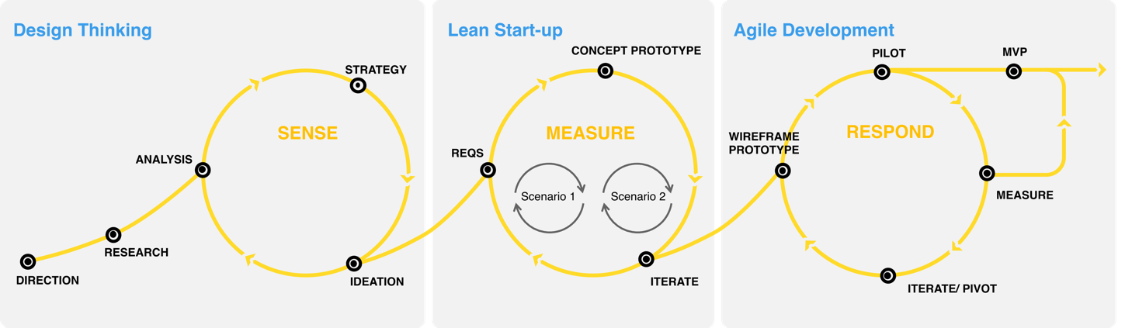

Advantages with DLAD:
Phases | Activity | CLIENT Phases | Expected Outcome | Projected Benefits
Discover | Business Priorities identified  Epics finalized | Co-design Phase | User journey maps  Personas | Rapid Prototyping facilitating more value to shippable product
Design | Prototyping & Test  Create end user journey | Co-design Phase | Storyboards  Service Blueprints  Wireframes | Zero deviation from the agreed product features.
Development | Design Led Agile for Business  Track and optimize from concept to adoption | Project Increment (PI) | Incremental Release  MVP validation | Bring technology closer to business, where the real value lies.
Deployment | Automation & Personalization  Deep understanding of adoption process | Project Increment | Real time bug fixing and QA  Updated product roadmap | Faster Time to market

KSF # 4: Continuous Testing to ensure Quality

- Our Thought leadership:

Following the recommendation of the VAGO audit report of May’2021, we strongly plan to adopt Continuous Testing (CT) practice as part of Developmental Sprints (CI-CD-CT).

- Our value proposition: Intelliassure (Wipro IP)

The diagram below illustrates our recommended Continuous Integration Test Approach. While the end-to-end integrated acceptance tests, performance tests, security tests and other non-functional tests are conducted before every release, we strongly recommend performing the component acceptance tests, component performance tests, component security tests, functional tests, automated tests, and continuous integration tests as part of every sprint to shift testing left to detect and fix issues at the earliest.

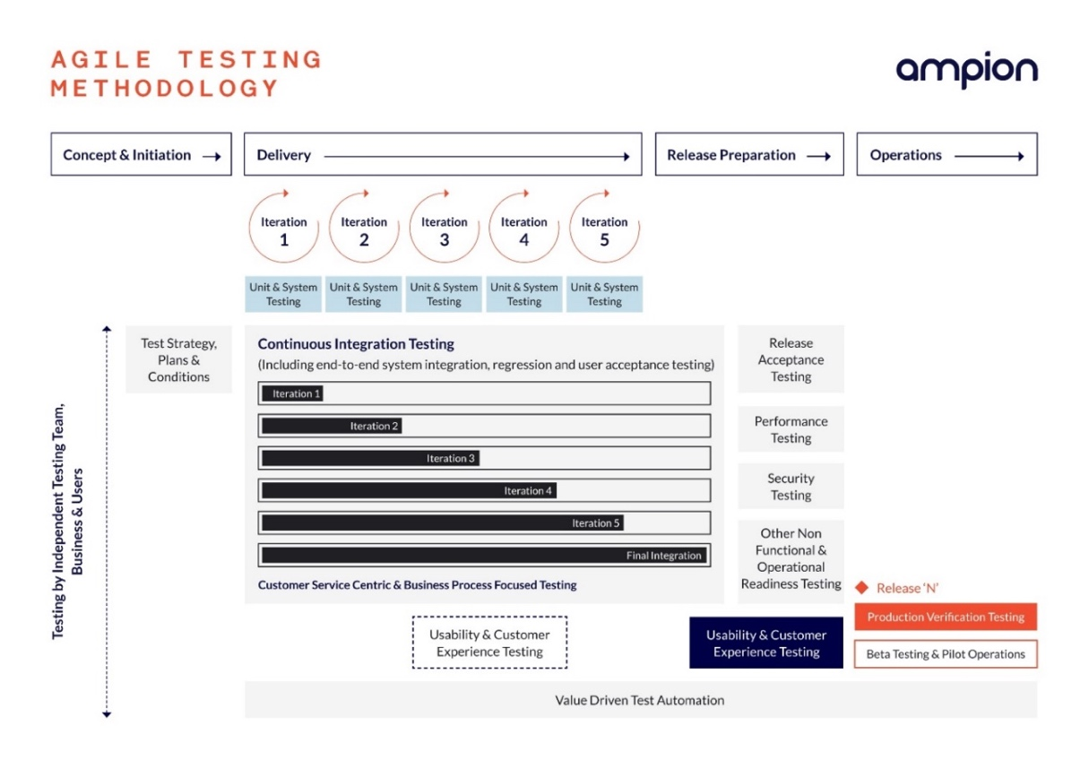

Our development team will follow TDD / BDD / ATDD approaches to make sure that they automate the unit tests for the source code delivered with-in every sprint. These tests will be executed automatically as part of every build and every deployment to make sure that the new source code does not break the previously working build inadvertently. This approach significantly speeds up the regression test execution cycle times.

To bring more power to our Testing proposition, we are strongly positioned with our IP, called, “wipro intelliassure”, which integrates with tools such as Tricentis Tosca and Selenium to provide a Test framework that supports Agile methodologies. [Details of this mentioned in sec 2.3 of this document]

KSF # 5: New Ways of Working

- Our Thought Leadership

We bring New Ways of Working to delivery engine, where we move away from traditional approach of single skill-based resource team to more of cross skilling, multi-disciplinary teams that collectively can work on multiple areas to deliver end to end functionalities.
- Our value proposition: Cross-functional team, Rapid Talent Transformation

As demonstrated below, we propose the cross-functional team structure to deliver the NextGen program to CLIENT.
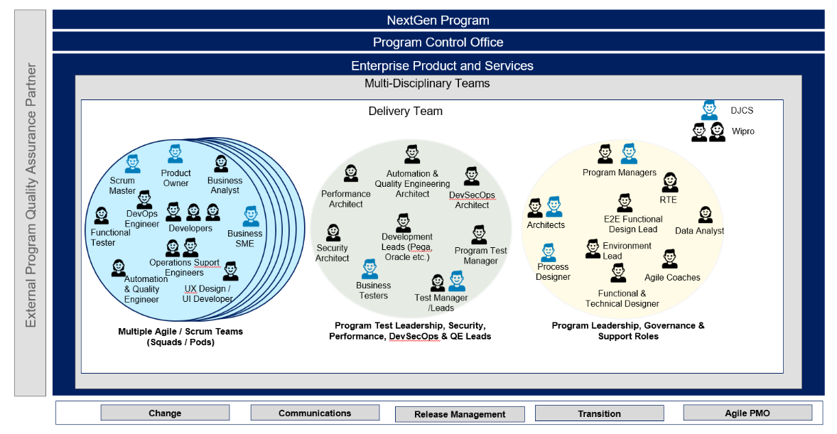

Our rapid talent transformation approach revolves around our principle of moving away from an “I” shaped to “Pi” shaped (rather X-shaped) team construct with more multi-disciplinary skill set, as illustrated below.

KSF # 6: Strong Governance Model

- Our Thought Leadership

We propose a delivery & transformation governance model that allows for continuous collaboration & commitment between the CLIENT & Wipro, at portfolio, program & team level, through an inclusive Governance Layer (incl. Gateway Review process as guided by the VAGO Audit Report, May’2021).

- Wipro’s unique value proposition to help CLIENT:

Through our proven governance mechanism, we are confident to establish a sound Governance practice for the whole of NextGen program, as illustrated in the following section.

In addition to establishing a strong Governance layer, we also recommend Balanced Score Card approach towards building a metrics strategy, to drive the program goals more effectively and thereby controlling cost/scope creep. A sample Balanced Score Card is given below. Based on the type of metric, periodicity can be at the end of the sprint, release, project etc. and can be made available real-time.

These are the recommended metrics to track for an Agile project once the team stabilizes. However, the final metrics need to be agreed in consultation with the stakeholders and with the support from the Coach based on the business goals and revisit the metrics as the organization matures over a period.

KSF # 7: Continuous Tech Innovation

- Our Thought Leadership

Through the tech innovation initiative, we would ensure a sustainable tech growth throughout the three phases of the engagement, which we envision to structure during the “Co-design” phase through “Foundation” phase and subsequently, cascade the benefits as we progress into year-2 and year-3 of the program. We bring differentiated product strategy through our constant technology innovation framework which is broadly classified as below:

- Our value proposition: Product Innovation

Our proposed Tech Innovation CoE will facilitate both foundational services as well as ongoing support to both the Innovation and BAU aspects of CLIENT’s Digital Pod (Sprint Team) set-up.

The foundations services comprise of:
  - Establishing strategic alignment with business for technology adoption
  - Defining Architecture/Technology Vision and Technology Standards
  - Create and maintain an architecture repository
(as-is, to-be, gaps and reference architectures)
The ongoing aspects that support Innovation would be:
  - Provide Architecture & Technology Advisory for innovation themes and projects
  - Provide Architecture Governance
  - Support Architecture Capability Development

Advantages of Tech Innovation:

- To enable a strategic approach to architecture definition.
- To support Innovation and Improved IT Forecasting by leveraging emerging trends.
- To optimization of IT Solutions by identifying common approaches, technology standardization.
- Improved Efficiency through improved interoperability and architectural coherence.
- Better Architecture Governance and ensure compliance with agreed upon architectural principles, standards, best practices, and roadmaps. Facilitate cross-department architectural collaboration.

KSF # 8: One team Culture

- Our Thought leadership:

For such an engagement involving multi-disciplinary teams, we recommend a “Badge less” approach and embed resources within customer led environment to co-create business and technology solutions. Adopting new way of working together focused on collaboration and continuous improvement will be a key to the engagement success.

- Our value proposition: Agile Anywhere

Wipro will create “Communities of Practices (CoP)” to drive engagement, collaboration and knowledge sharing. These CoPs would bring people with similar interests together i.e., CoP for CI/CD engineers that will unite all CI/CD engineers from across various teams. We will also schedule joint team building activities involving CLIENT and other partners to create a sense of connection amongst people working on the NextGen program. The pictorial representation below, depicts this key aspect.

Even during the unforeseen times, like the one currently the world is experiencing, we have our unique “Agile Anywhere” framework, which enables guiding principles to bring the People, Process and Technology together to deliver successfully, through safe and secure infrastructure, right tool kit, proper collaboration platform, self-organizing working style, adopting modern engineering practices.

KSF # 9: Effective Change management (CM)

- Our Thought leadership:

We adopt a persona-based approach to deliver the change, as opposed to traditional approach of ‘broad brush’ method of delivering the same message and training to everyone.

- Our value proposition: Engage, Align, Enable

Our change framework addresses adoption and business readiness for technology solutions, through organizational alignment, communication, change strategy, stakeholder engagement, building competency, as explained in the table below:
Change Drivers | Wipro Implementation Principles
Organizational Alignment | - Aligning CLIENT users to new standard processes, policies, and procedures  - Aligning new roles and responsibilities will allow for role clarity
Communications | - Integrated communication plans, by region to consolidate messages, as required  - Allows CLIENT to be prepared through initial cascades to them before employees
Change Strategy | - Manage CLIENT people risks through the Wipro CM methodology  - Identify and close gaps leveraging the Readiness Assessment
Stakeholder Or Persona Engagement | - Engaging CLIENT stakeholders is a leading practice toward adoption  - Establishing routine change network meetings allows for two-way communication and identifies pockets of resistance
Skill and Competency | - Select the right people for new roles within the department.  - Identification of critical skills  - Workshops on how to work in a managed services environment

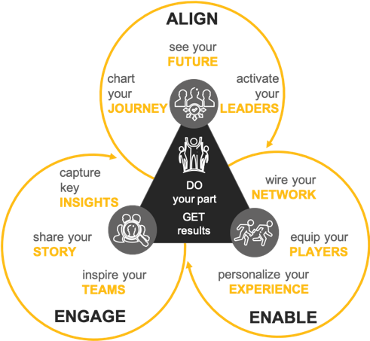
The illustrative diagram, below, summarizes how we envisage to execute seamless organizational change management across CLIENT departments post implementation of the NextGen program.

Key risks and challenges
Please describe the key risks and challenges that CLIENT may face in implementing the NextGen solution along with suggested mitigations. Tenderers may add additional rows as required.
Risk/challenge | Mitigation(s)
On-time staffing of niche skill resources | Wipro has a large pool of resources across the in-scope technology and skills areas who are available to be deployed. This is backed by our robust demand management function which will ensure visibility of upcoming demand and ensure timely fulfilment. We will create early and comprehensive, resource requirement and any training needs analysis which we will feed into demand management and training curriculum and delivery methods to cater to requirements. But for certain niche skill areas, we propose leveraging the Digital Academy for anticipated needs and our Talent as a Service (TaaS) Crowdsourcing for immediate needs. [we have covered that in detail in sec 3.2 in this document]
Adoption of Change | We bring a wealth of experience in working with public institutions and have a keen sense of appreciation of the magnitude of changes the new solution will bring to internal and end users of the current platform. For this we propose including the representative sample of key users right from the beginning, which will help mitigate this risk and ensure higher adoption to the solution.  This will be followed up by a robust change and communication plan which will drive both by top down and bottom-up approach. We recommend bringing in change agent networks to drive program engagement with early and regular readiness assessments using agreed criteria to identify pockets of resistance and follow-up action plans supported by change. [we have covered that in detail under key critical success factor in sec 2.1, KSF #9, in this document]
Change in organization priorities due to external factors leading to delays in the schedule | We advocate the strong review mechanism under the program leadership and governance structure with Business and Technical Product Managers, Agile Coach, Release Train Engineer etc who will continually track and groom the overall programme priorities across all levels of the engagement. Under this any changes to overall ecosystem will also be considered such as dependency on other programs, Issues with integration between different solution components and existing systems thus ensuring the overall outcomes are on schedule.  For any major changes that need to be made, we will jointly identify the change, estimate the impact and will evaluate the impact on scope, time, resource requirements to make the updates and validate it against the delivery timelines. Together with CLIENT, a collaborative decision will be made to decide on the appropriate prioritisation of features and overall timelines.
Issues due to inaccurate data quality  - Duplicate data  - Decentralized rules | - Data quality assessments of the legacy system needs to be provided by CLIENT before the start of the engagement. Data Profiling needs to be done well in advance and have clear action plan how to address these quality issues. Wipro will leverage existing tools such as Informatica and other tools in this activity to mitigate this risk effectively  - Reports on data quality will be provided throughout the project. Through the VIEW replica DB and implementation of Change of data capability of our Informatica MDM, we will ensure we have data coherence. This will help track the data quality improvement during the project timelines  - We will institute robust data quality and governance program through Informatica’s DQM capability.  - Rationalize Master Data Management function into one core system which becomes the single source of truth, which is what we are going to deliver at the end of year-3 of the program.  - Centralized data quality rules for easy maintenance and versioning

2.3 Scope of services to be delivered
Clearly summarise the scope of services you are proposing to deliver to CLIENT. Please ensure your response has considered the details outlined in the Part B Schedules
Scope of delivery services:
Our Response On: Understanding of Part B Schedules
We have read through Part B Schedules and have familiarized with CLIENT business and technology landscape. Wipro has lived the journey of defining the NextGen platform with CLIENT through architectural POC undertaken in the year 2020, where we had demonstrated our understanding of your given use scenarios in the “Payment Arrangements”, “Enforcement Review”, “CWP”, using Pega (PRPC v8.5) and Oracle Integration Cloud (OIC), basis an interim architectural model which resembles to that of the scope of this RFT.
To arrive at a view of the scope of the services, we have analyzed the following artifacts shared as part of the RFT:
Sl. no. | Part B Schedules | Understanding gained
1 | Business Capability Model | To understand the core capabilities envisaged from the NextGen platform which also provides views around Service overlay as well as Process overlay.
2 | Requirement Repository – | To understand 260+ capabilities that define CLIENT’s target business model.
3 | Service Framework & Service Concepts (14) | To understand the desired level of service experience, business mapping to business capabilities, which CLIENT has already embarked upon.
4 | Service blueprints and moments that matter | To understand future experience (though limited to four core users) and eight ‘moments’ of interaction/experience transformation.
5 | Technology Solution Specification & SAD | To understand the logical solution components, modes of operations, phased program plan, program delivery model, etc.

Our Response On: Understanding of Scope of Services
After going through the SAD document (Part B Schedule SAD), we understand the following platform capabilities need to be covered as part of the solution components, and we comply in terms of delivery proposition, as shown below:

Logical Components | Our Scope Coverage | Proposed-Product Components
Accounting Platform | NOW phase of Nextgen program | Oracle FMS
Business Intelligence Platform | LATER phase of Nextgen program | NA
Business Process Management | NOW phase of Nextgen program | Pega -PGP BPM
Case Management Platform | NOW phase of Nextgen program | Pega - PGP
Contact Centre Platform | LATER phase of Nextgen program | NA
Customer Relationship Platform | NOW phase of Nextgen program | Pega – PGP CRM
Digital Channels Platform | NOW phase of Nextgen program | Drupal
Document / Records Management | NOW phase of Nextgen program | Micro Focus
Enterprise Data Management | NOW phase of Nextgen program | Informatica
Identity and Access Management | LATER phase of Nextgen program | NA
Integration Platform | NOW phase of Nextgen program | MuleSoft (Oracle Integration Cloud)
IT Delivery Support Platform | LATER phase of Nextgen program | NA
IT Operations Support Platform | LATER phase of Nextgen program | NA
Managed Security Platform | LATER phase of Nextgen program | NA
No/Low Code Application Platform | NOW phase of Nextgen program | Pega – PGP
Operations Management Platform | NOW phase of Nextgen program | Pega - PGP

Please refer to our RFT submission doc: Part D Schedule 2 Solution Architecture Response for detail view on the individual bundles as well as interoperability among the bundles with detail data view, integration view, core platform view, etc.

Summary of Bundle wise Scope of delivery:

Bundle | Components | Scope of Services Y1 | Scope of Services Y2 | Scope of Services Y3
Core Platform (1a) | Pega (LC/NC) | - Setup the Platforms and Environments with end-to-end connectivity​  - Obligation data records (eligible for sanctions) intake to NextGen from View Replica DB ​  - Obligation review lifecycle ​  - Warrant enforcement and sanctions lifecycle (no mobile app in MVP-1)​  - Integrations - Oracle FMS, Drupal Portal, ODS/MDM​, VicRoads, SERCO TCS, Enforcement Agencies, VicPol. PERA, BDM​, LDAP/AD​ | - Ingestion of Obligations into NextGen ​  - Debtor matching, merge and unmerge (with MDM integration)​  - Sheriffs Mobile App​  - Asset seizure capture​  - Operational Reporting in Pega and BIX extracts for BI​  - Enhancements/Additional Integrations with MDM, Drupal Portal, Oracle FMS, ​  - Integration with Google Maps​, Magistrate Courts, County Courts​ | - Sheriff special operations management​  - Debtor Payment arrangements​  - Operational reporting in Pega​  - BIX extracts for BI reporting​  - Court fine intake into NextGen​  - Enhancement/additional Integrations with Oracle FMS, Drupal Portal, ODS/MDM​, Magistrate Courts, VicRoads, PPSR  - Integrations with Court systems​​
 | Oracle (FMS) | Oracle ERP Cloud implementation modules. Integration with PEGA for transactional and master data. Integration with banks and reconciliations | Synchronization of debtor and creditor data with MDM. Integration support from PEGA and MDM. | Integration support from PEGA and MDM.
 | Integration (Mule) | - Mule Platform setup  - Configuration of CI/CD | Build services for  - VicRoads  - Magistrate Courts  - Country Courts  - Serco TCS  - BDM (Births/Death/Marriages)  - Enforcement Agencies Portal  - Fines Victoria  - Centepay  - Westpac Banking | Remaining services  - Australia Post  - VicPol - Supporting systems  - Trasnurban (Citylink)  - EastLink  - BPO Telephony(IVR) (Payment system)  - BPO  - PPSR(Personal Prospects Security Register)  - Corrections Victoria
Data Integration (2a) | MDM - Informatica | MDM – Application set-up, Enterprise data model configurations – Debtor, Creditor & Reference data, Integration with PEGA, Oracle FMS for master data search & validation, CRUD process for Creditor, Reference data | MDM – Master data migration and consolidation process including match & merge rules configuration, Golden record creation, | MDM – Debtor match tuning, MDM process refinements, Integration with other applications for master data democratization
 | Informatica IICS | IICS, IDQ and CDC platform setup, Data model Setup for data migration.  Data Migration to Next Gen application of data VIMS and VIEW  Data Governance process setup and implementation | Data Migration to Next Gen application of data VIMS and VIEW  Data Synchronization between VIEW and Next Gen applications | Data Ingestion
 | Informatica DQ | Import the Source data and prepare the profile reports and dashboard.  Define the DQ rules and integrate with the ETL pipelines | Monitor the DQ rules and improve the process.  Import the data Integration Sources | Monitor the DQ rules and improve the process
 | Informatica EDC | Setup the EDC platform and import the Sources, stich the data Linage. Create Technical meta metadata. | Improve the Data Linage process and create technical dictionary for Semantic search | Improve the Data Linage process and create technical dictionary for Semantic search.  Integrate with AXON data dictionary and
 | Informatica AXON | Setup the AXON platform and import the Sources, meta metadata.  Create data access policies  Create Business Glossary | Stabilize and improve the process  Integrate with EDC pull and push the data to manage the data governance. | Manage the Platform.
Document Management (3a) | Micro Focus – CM (HP Trim) | EDRMS design (including classifications and disposal schedules), configuration, documentation. | Provide functionality development  Development of custom ingestion tools for Worksite migration to Content Manager | Supporting operational manual to assist ICT and SME in operation and maintenance of software implementation
External Interfaces (4) | Portal - (Drupal) | NA | Portal functionality connected with PEGA, IDAM through MuleSoft, for debtor functionality | Any Enhancements or new application /functionality
DevOps (CI-CD) (5a) | CI-CD automation | Study, design, implement CICD and onboard foundation modules | Iterative onboarding of additional modules​ | Transition and mature

Following the guidelines suggested in Section-7 of the Part B Schedules (Technology Solution Specifications), we have summarized the delivery model in the following manner:
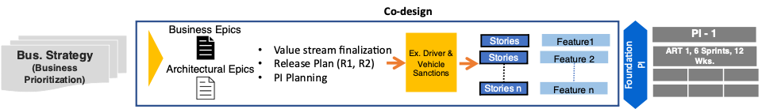

To deliver the aforesaid scope of services, we will follow the Human-centric and Value metric driven Application Development, as has been graphically represented below:

To bring in high velocity into engineering deployed by us for CLIENT, will adopt a rapid experiment oriented, data driven, fail-fast/learn-faster progressive approach through continuous strategy/design/delivery. Our proposed engagement model is built on the strong foundation Agile framework and addresses the needs of CLIENT. Our design-led agile delivery model will involve the following:
- Understanding business priorities, Epics
- Value stream finalization
- Product feature finalization
- Alignment on user journey, persona, wireframes
- Final view of user stories – product features
- Foundation PI Planning – Sprint estimation

Our program delivery is based on two-pronged approach:
- Innovation Lighthouse
- Acceleration Cell

As As part of transformation modelling, we will establish Innovation Lighthouse pod as a capability to continuously glean on industry insights & your business problems to arrive at innovative ideas to solve them. Lighthouse will be an attempt by Wipro to come up with disruptive industry insights and formulate a strategy before they can be taken to industrialization. Industrialization of these MVPs will derive business values for overall execution of the platform.
Typically, Light house pod will be a multi-disciplinary team of 6-8 co-located Customer and Wipro colleagues. This team will be primarily responsible for:
- Business interaction
- Market insights focusing on priorities
- Architecture enhancement, technology gap analysis and insights
- Program backlog grooming and vision

Acceleration cell will comprise of multi-disciplinary teams of product owner, scrum master, design/UX, functional domains and technology proClientsionals working in ring-fenced manner to deliver business centric outcomes. We will leverage existing DevOps & CI/CD infrastructure or augment tools (as needed), underpinned by continuous delivery discipline allowing teams to incrementally mature propositions through experimentation. These Acceleration Teams are a rearrangement of existing team on need basis and not costed separately. These teams work independently as a unit to deliver different activities like Development and Application Maintenance. Key activities of these pods will include:
- Implement design, build governance structure, and ensure governance followed
- Work towards impact assessment and feasibility analysis with Product / Service / Process team
- Support Infrastructure readiness and provisioning
- Captures reuse across multiple implementation
- Supports activation at rapid scale
An overview of the Lighthouse and Acceleration Cell construction as we envisage is as illustrated below:

Key attributes of proposed operating structure are as follows:
- Agile operating model with focus on delivery business value.
- Innovation Lighthouse to be co-located with CLIENT and bring in thought leadership and a mandate to innovate & license to deliver
- Acceleration Cells to be on-boarded to execute autonomously & deliver with fast turnaround times.
- Integrated Governance, Light House and acceleration project execution and delivery teams
- Acceleration Cell model to meet spikes in demand
- Leverage CLIENT eco-system and synergies
- Digital Academy to enable talent transformation
- Wipro ecosystem to support execution and innovation

Advantages with Lighthouse construct:
- Business Sensing: Glean on insights from citizen and regulations standpoint
- Proof-of-value by identifying innovative solutions to business problems, prove their values with MVP
- Secure business stakeholders’ buy-in to take successful MVPs for scaling & implementation
- Amplify quick wins to build momentum & engage employees/users to drive zero touch adoption of successful change
- Establish governance working groups with empowered leaders invested in achieving business case and drive change

The basis of core execution will be Agile Based acceleration cells which will be working to deliver a Minimum Viable Product and scaling as and when needed. As an organizational principle, it ensures a holistic perspective and speedy collaboration across all concerned stakeholders. In close collaboration with CLIENT, we will organize the talent into multi-disciplinary & accelerated cells. Our adoption ONE team construct is proposed with scalability of multiple acceleration cells to deliver the MVPs, as shown below:

We will setup ‘fully stacked’ agile teams that deliver measurable outcomes. The acceleration cells are characterized as following:
- Agile Development & Operating Model
- Full stacked persistent teams
- Continuous Integration, Continuous Deployment to Pre-Prod
- Experience-driven Product Management
- Design-led Continuous Engineering
- Security baked in as part code – DevSecOps
Following is the high-level representation of our End-to-End delivery model and approach with the complete visibility of our proposed delivery construct with Innovation Lighthouse with acceleration cells, along with our resourcing process to staff niche skills.

Our Overall Testing Coverage to Support the Program

Based on the previous lessons learned at CLIENT, we understand that testing is one of the critical success factors for the NextGen Program. As suggested in the VAGO audit report of May’2021, we strongly underpin the idea of having a robust Testing to deliver high quality business solution successfully to CLIENT.
We follow “left-shift” testing approach for large transformation programs of the size of that of NextGen. Along with CI-CD we, recommend Continuous Testing (CT) at every Sprint level. Overview of the test solution and testing best practices in agile SDLC:

- Testing team participates in storyboard creation during the Program Increment (PI) for testability analysis and acceptance criteria based on customer requirements.
- Alignment of test strategy and planning with prioritization for story card to adopt the right approach for the testing.
- Entry/Exit criteria-based Quality Gates to ensure best in class quality of deliverables.
- Identify non-functional requirements that cut across stories early, Storyboard traceability across iterations for requirement assurance and CR management.
- Periodic refactoring of test cases to reflect the CRs.
- Plans for testing in early Iteration planning meeting (Iteration Zero).
- Continuous integration and updated Regression test suites to have ready to deploy application.
- Measurement of test processes/activities through agile specific metrics such as Post Sprint Defects, Post Release Defects, Burn Up/Down Charts, Agile Effectiveness Index.
- Shift Left Approach to ensure early involvement of Non-functional testing team (Performance, Stress, Security, Accessibility) in SDLC in improved requirements capture, design and phase containment of defects.

We achieve the aforesaid through our proven Agile QA delivery model as illustrated in the following section below:

Some of the key test components we have factored for this program has been summarized in the table below:

Proposed Testing Phases | Planned Activities
Functional Testing | - Functional test engineers will be embedded in each of the scrum teams.  - Test lead will work closely with the product owner to understand the user stories scoped for the sprint delivery.  - Testing team will map the user stories appropriate requirement  - Test case design, development and execution will be completed by the team  - The regression test suite will be updated based on the sprint deliverables
Automation Testing | - Based on the scope of development, Wipro proposes to deliver a hybrid automation framework comprising of Selenium and Appium for web and mobile applications respectively  - Test architect will outline the automation test plan and the identified test cases will be added the automation backlog  - Typically, the regression test cases are prioritised followed by the remaining test cases that are frequently executed  - Automation framework will be integrated with the test management tool such as jira for automated reporting  - Automation framework will be embedded in the CD/CI implementation and the sanity checks of the feature to be deployed will be tested by the automation framework
Performance Testing | The following approaches will be applied to test the performance of the NextGen platform implementation and related services/integrations  - User Experience Testing: End user performance experience by executing various tests as applicable after transformation to ensure optimum performance  - Scalability Testing: To measure the scalability of the solution with increased user load for agreed concurrent users of critical process flows  - Identify the performance bottleneck and provide suggestions/recommendations for performance improvement  - Optimize test coverage and automate activities across the life cycle as applicable using tools capability and expertise  Using JMeter solution, the automated scripts will trigger synthetic load on the backend systems connected to NextGen Platform and the above tests will be conducted to verify the performance benchmark
Accessibility Testing | Following are the key areas of activities outlined for CLIENT for accessibility testing:  - 50 different standards defined for WCAG 2.1 – A and AA. Depending upon the type of page, applicable standards will be selected for conducting the testing.  - Websites have responsive design and hence will be tested on iOS and Android phones.  - Mobile apps will be tested on iOS and Android phones.  - At the end of the testing cycle, an Accessibility Non-compliance Audit Report will be generated, comprising of application details, all the standards it is not compliant to and description of defects identified.
API and Integration Testing | With the help of integration between API automation Scripts, Jenkins and GIT Repository, we will design Framework for the creation of Continuous Integration (CI) and Continuous Delivery/Deployment (CD) pipelines. Below Testing strategy will be introduced for implementing robust API test automation:  - Input argument values - Boundary values, equivalence partitioning  - Parameter Combinations - Combinatorial testing  - Error Validation - Exceptional handling and output data with error codes  - Data Integrity validation - Verify if the API is updating any data structure  - Scenario testing - Sequence of API calls, E2E scenario testing  - API Gateway tests- Ensure requests from multiple Clients are handled as agreed
We understand the importance of Testing for the overall success of the program. Therefore, to further strengthen, out testing proposition we have thought about bringing some of our Testing IP/Accelerators to bring efficiency into the overall quality assurance scope. Below, we present a snapshot of quality engineering IP, intelliassure, managed QA delivery platform powered by Hyper Automation, Analytics and QA Best Practices:

Our IP proposition for the NextGen Program is as follows:

Testing IP/Accelerators Proposed | What it does | Benefit to the Program
Intelligent Defect logging | Elimination of duplicate defects and auto-classification of defects through machine learning algorithms | Zero chance of defect missing out, which is a big risk to the program at any stage of MVP.
Regression Tester - Machine Driven Regression | In-built Algorithm to crunch the input data provided by the user for generating the optimized regression suite and providing a BOT Audit report for SME review. Intelligent orchestration of 4 BOTs to mimic the activities in a “Day in the Life of a Regression tester”. | More productive and effective than a manual regression tester.
Test Asset Optimizer | Optimization of Test Assets scientifically through Ontology / Semantics Algorithms | Reduced dependency on Application SME, saving the productive business time for them.
Automation Failure Analysis | Enables analysis of automation execution failure logs through machine learning based classification of failures – ability to process different file formats XML, HTML, CSV, etc. | Saves efforts/resources to track failure logs.
Our high-level Implementation plan to deliver the scope of services:
We propose a 36-months delivery schedule consisting of 10-Program Increments (PI) while VIEW continues to co-exist with NextGen. Each PI will deliver specific use cases where functionality does not exist in VIEW with the foundational layer being the first PI. Each PI delivered will CLIENT start getting a debtor centric view and enable self-service while pulling data from the VIEW systems. . Each PI will have a unique design to prototype to build to scale capability that will showcase the development to CLIENT stakeholders ensuring business outcomes are achieved.

Before we conclude this section, we would like to highlight some of the delivery dependencies as well as some of the activities that are not part of the scope of the delivery for NOW phase (scope of this RFT):
- Dependency Matrix
Sl # | Dependency | Description
1 | Availability of all identified CLIENT stakeholders such as Data Protection officers, Application Team, Security Team for meeting in a timely manner. | At the co-design phase – approx. 6-8 weeks
2 | Availability of all identified CLIENT stakeholders (Business units, Risk Office, legal and privacy teams) for meetings and granting approvals in a timely manner | During the Sprint UAT stage – approx. 1 week
3 | NextGen solution will depend on the incumbent contact centre telephony system for IVR/IVVR and call recording capabilities, which can deliver call recordings as files to NextGen solution for storage. | Should be accessible at the time of developmental Sprints.
4 | NextGen solution will depend on the incumbent service provider for OCR capabilities, which can deliver the structured data to NextGen solution through integration | Kofax systems should be made accessible at the development, UAT phases.
5 | NextGen solution will depend on Google Maps to render the map, place indicators on the map and provide route directions between destinations. | GMap interface should be accessible to the development team.
Note: Detail Dependency Matrix has been provided for further study in our response to Part D Schedule 2 Solution Architecture doc.

- Out of Scope (for “NOW”)
Sl No. | Activity
1 | Service Design, Service Blueprint, User journey mapping and Wireframe development
2 | Security Management & Identity Set-Up
3 | OCR Implementation is not factored in the scope. We will leverage existing Kofax solution.
4 | Implementation of payment Gateway is not scoped. We will leverage Govt. real-time payment gateway APIs.
Note: Further detail has been provided in our response to Part D Schedule 2 Solution Architecture doc.

- Our AMS Proposition for future consideration (Post Transition & Mature of NextGen)

Wipro has invested in industry leading comprehensive next generation RUN framework – Service NXT™ , which provides a seamless and integrated approach to managing the enterprise and SaaS applications, IT infrastructure, enterprise security and cloud operations supported by People, Process & Tools and structured as three-layer framework – Proactive, Preventive and Predictive. Service NXT framework is powered by Wipro HOLMES™ – Our Artificial Intelligence platform is a rich set of traditional and cognitive automation services. HOLMES™ is developed using machine learning, natural language processing, genetic and deep learning algorithms, semantic ontologies, pattern recognition and knowledge modelling technologies to provide solutions that deliver cognitive enhancement to experience and productivity, accelerate process through automation and at the highest stage of maturity can reach autonomous abilities.

Our solution levers and projected benefits envisaged for DJS has been outlines in the table below. We call it EASE approach to simplified operating model for application maintenance services, as demonstrated below:

Key Tenets | Solution Levers | Projected Benefit for CLIENT
Experienced Ecosystem (E) | - Service Ownership & Collaboration  - Persona driven integrated service delivery  - Single pane of glass reporting on service performance | - >20% improvement in first call resolution (FCR)  - Improved user satisfaction  - Significantly improved context of service delivery  - 100% Service accountability and SLA adherence
Agile (A) | Bi-modal operations where Agile/DevOps co-exists. | - 40% faster Time to market  - Accelerates portfolio simplification
Simplified Operations (S) | Harmonized target operating model (TOM) with industrialized delivery and close alignment with business teams | - 20 -25% Improvement in Mean time to resolve (MTTR)
Efficient-Economical (E) | - Automation First approach  - AIOps - Applying AI tools/platform & processes in service delivery  - Right shoring of services - A global delivery model and right shoring of services  - Fit for purpose operating model driving automation, elimination, and left shift to improve efficiencies  - Continuous Service Improvement embedded in service delivery | - 20% - 25% IT spend reduction  - > 25% Productivity Improvement  - 25 – 30% Improvement in Mean time to detect (MTTD) for Incidents  - 20 - 25% ticket reduction

3. Capability and Capacity to deliver services

Organisational overview
Provide an overview of your organisation in terms of how it is best positioned to support CLIENT. Tenderers are encouraged to address the following topics in their response:
- Organisational vision and mission
- Core organisational capabilities
- Key differentiators in the market
- Organisational culture
- Ways of working and collaborating
- Innovation and thought leadership
We are a global technology services firm, powered by our talent of over 197,000 people. We have employees in over 65 countries & serve enterprise clients across 27 industry segments. We harness the power of design, cognitive computing, hyper-automation, cloud, analytics and many other emerging technologies to help our clients adapt to the digital world to provide them competitive advantage in their markets while ensuring resilience and cyber-assurance. We work with them not only to enable their digital future, but also to drive hyper efficiencies across their technology infrastructure, applications and core operations, enabling them to achieve cost leadership in their businesses.
We are recognized by our clients for our ability to bring in ‘’an integrated perspective’’ i.e., ability to bring together broad and deep technology and domain expertise, ability to draw learnings and apply insights from one company or sector to another & our ability to provide end-to-end capabilities and services. Our clients value our consistent excellence in execution, our ability to bring in relevant innovation pro-actively and ease of doing business with us.
Wipro started its journey in Australia over 20 years ago, and since then we have been a vanguard, bringing new technologies and significant digital transformation to this continent. Successfully delivering several transformational programs, in both the private and public sectors, has strengthened our presence in Australia. We are actively working with several enterprises including federal and state government departments and agencies to drive innovation by leveraging our expertise in hybrid cloud, analytics, application modernization, and artificial intelligence. Wipro has been a pioneer of new age, disruptive, and transformative innovations. Our presence in Australia has been firmed up with a multitude of transformational programs that have been successfully delivered over the years in both public and private sectors. We proudly serve customers across diverse industry segments with at least a third listed in the top 100 ASX. Our customers include Woolworths, AMP, Sydney Water, NBN, University of Sydney, AusNet, and many others.
Our fundamental business/operating model is based on delivering a comprehensive (end to end) portfolio of services (i.e., Consultancy, Design, Engineering, Implementation, Operations) to our clients. So, deprioritizing specific service offerings will be counter-productive. As customers want to work strategically with a few select partners with fewer necks to choke, the legitimacy of this model only increases.
Keeping pace with the agility in the way our customers work, to meet their business demands, we have always been endeavouring to make our services organization as flat as possible as closest to the customer as possible. In lieu of our constant efforts we have recently restructured ourselves to take our services and offering to where our customer are. Please find, below, the new Wipro for you.

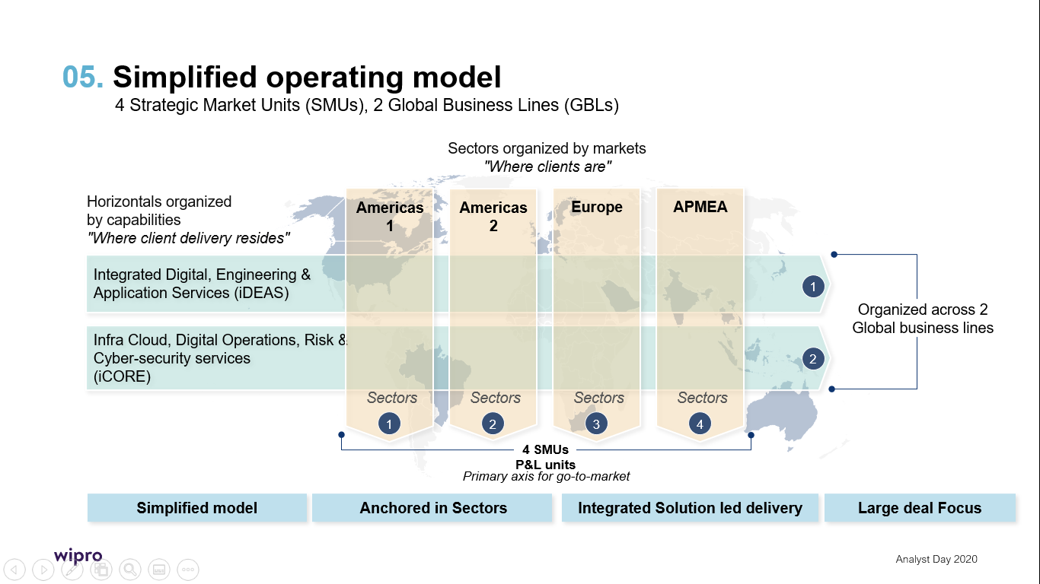

- Organizational vision and mission

Wipro’s Vision:
- Be a trusted partner to our clients in their transformation journey and enable them to achieve leadership and outstanding business outcomes.
- Deliver industry-leading value to our clients through sector focused ‘Business solutions’, digital capabilities, leading-edge innovation leveraging our strategic partnerships, and world class talent.
- Our greater purpose is beyond just winning in business. It is our unwavering commitment to the society, our communities, and a sustainable planet we work and live in.

Our Values:
The Spirit of Wipro:
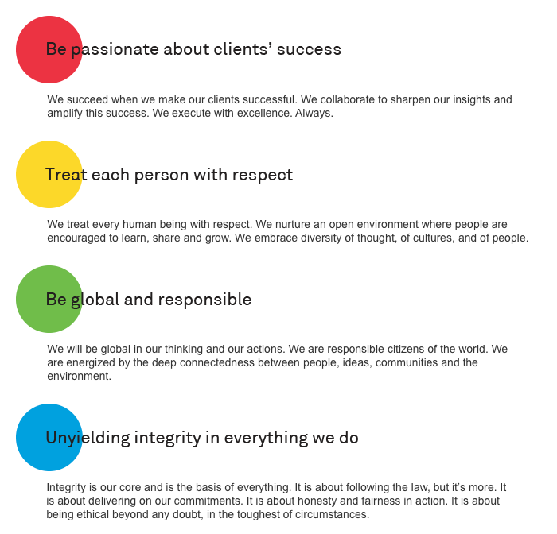

- Core organisational capabilities
We are a leading provider of IT services to enterprises across the globe. We provide a range of services, which include digital strategy advisory, customer-centric design, technology consulting, IT consulting, custom application design, development, re-engineering and maintenance, systems integration, package implementation, global infrastructure services, business process services, cloud, mobility and analytics services, research and development and hardware and software design. We offer these services globally leveraging our products, platforms and solutions through a team of over 180,000 employees using our global delivery model. Our key service offerings are outlined below:

Integrated Digital, Engineering and Application Services:

Digital Interactive and Digital Experience:
Wipro Digital helps global enterprises transform their business, IT and customer experience by leveraging design and technology. As companies define a new normal, CIOs, CMOs and other key stakeholders partner with us to create healthy, resilient and agile businesses.
Our end-to-end offerings encompass Product Strategy and Design, IT Operating Model Transformation, Digital CMO, Intelligent Processes, and High-Performance Software Engineering. These areas form the backbone of our clients’ transformations and are central to helping them build resilience throughout their organization.

Cloud Transformation:
Enterprise applications provide a strong IT backbone to organizations, many of which are grappling with technical debt from legacy systems, unable to support the agility needed by modern businesses.
We drive the “digital flip” of these applications and enable the digital transformation of businesses, helping them reimagine the businesses and their models by fundamentally changing how value is generated by the enterprise, and how value is delivered to consumer.

Engineering Research & Development (“ER&D”) :
ER&D is the driver of our engineering services portfolio and facilitates more than 375 clients across multiple industries and/or verticals by providing a platform to innovate and engineer the products, platforms and technologies at scale. This platform of services offerings, called “EngineeringNXT”, combines the maturity of engineering processes, the passion for the latest technology and access to a diverse ecosystem to deliver value to customers at various stages of the product or platform life cycle.

Apps & Data :
As a preferred partner for our customers’ data and insights transformations, we help them in their journey to transform into intelligent enterprises by automating decision making, powered by insights and driven by rich datasets. Wipro leverages AI, ML, advanced analytics, big data and information management capabilities to deliver measurable business outcomes across customers’ journey from data to decisions, focusing on:

Insights transformation – Transforming legacy decision- making processes into modern, elastic and AI and ML driven, insights-centric capabilities that enable smarter processes. This ensures that our clients get pertinent insights in real-time to the right decision-makers to fuel innovation, productivity and investment, as their organizations become intelligent enterprises.

Data transformation – Helping clients adopt modern data platforms, processes and methods in on-premises, cloud and hybrid ecosystems to support analytics, AI and ML workloads through a set of themes that brings transformative change to the data landscape.

CRS - Cybersecurity and Risk Services :
CRS enables next generation global enterprises to enhance their business resilience through an intelligent and integrated risk approach that has modernizing security at its core. CRS enables the customers to define their cyber strategy and the cybersecurity needs, envisaging best practices across people, process and technology. Leveraging a large pool of experienced security proClientsionals and a global delivery model that leverages our Cyber Defense Centres, we execute projects and deliver managed and hosted services backed by our Cyber Defense Platform. Our unique top-down risk-based approach delivers innovative security platforms for better scalability, improved cost efficiency and greater agility.

DOP - Digital Operations and platforms :
Wipro DOP is a leader in providing next generation technology- led business process services to global enterprises. Our mission is to drive superior customer experience and maximize returns by bringing down operating costs and improving efficiency, quality and productivity. Our process excellence and domain expertise help us reimagine, redesign, standardize and transform business processes and enterprise operations transformation helps clients leverage and deliver benefits from RPA, AI, analytics and other emerging technologies.

IT products:
We provide IT products as a complement to our IT services offerings rather than sell standalone IT products.
We are value-added resellers of third-party enterprise products through our direct sales force. Our sales teams are organized by industry vertical. Our global client partners receive support from our corporate marketing team to assist in brand building and other corporate level marketing efforts for various market segments.

- Key differentiators in the market
The market for IT services is competitive and rapidly changing. Our competitors in this market include global consulting firms and IT services companies as well as local and niche services providers.
The following factors differentiate us from our competition:

- The comprehensive and integrated suite of IT solutions, including digital strategy advisory, customer-centric design, technology consulting, IT consulting, custom application design, development, re-engineering and maintenance, systems integration, package implementation, global infrastructure services, cloud, mobility and analytics services, business process services, research and development and hardware and software design.

- Crowdsourcing (Topcoder): A community and crowdsourcing platform with over one million developers, designers, data scientists and testers. Topcoder provides focused enterprise offerings around AI/ML and analytics, DX, QaaS, workforce transformation, TaaS and hybrid (certified) communities.

- Wipro Digital’s integrated propositions in customer mapping and interaction, seamless integration and data science and insight differentiate its approach with customer journey engineering.

- Our organizational culture of innovation and our early start in deploying cutting edge platforms and technologies that drive hyper-automation and achieve industrialization of service delivery, such as Wipro HOLMESTM.

- Our investments in developing IP across products, platforms, frameworks, solutions, components, accelerators, tools and apps that enable us to provide standardized solutions to our customers and obtain enormous time-to-market advantage.

- Our decades of experience in serving in the IT business, proven track record of delivery excellence and satisfied customers who recommend our services to other corporations.

- Our ability to provide an entire range of research and development services from concept to product realization.

- Our global delivery model, that leverages our global, regional and local near-shore development centers and collaborative technologies to help us better serve our clients in this modern technology era.

- Our ability to access, attract and retain highly skilled personnel across key markets.

- Our emphasis on engaging the culture of our new age acquisitions and integrating these technologies with our executional experience and service offerings to maximize synergies for our clients.

- Our ability to offer opportunities to work with cutting edge technologies and focus on training is a critical differentiator to the quality of our manpower.

- The Wipro brand that is recognized globally for its comprehensive portfolio of services, a practitioner’s approach to delivering innovation and an organization- wide commitment to sustainability.

- Our commitment to the highest levels of corporate governance.

- Organizational culture

Two culturally similar entities: CLIENT & Wipro

Cultural Match | Ethical Culture | Work Culture | Social Responsibility | Corporate Responsibility
CLIENT | Focus on victims and survivors | Open and independent | Integrated service for local communities | Abide by Law/Reforms Act from time to time
Wipro | Named in World’s Most Ethical Companies by the Ethisphere Institute 9 years in a row | Free and flat hierarchical structure | Highest philanthropic sponsorship by the Chairman of Wipro.   | Sustainability at the Core  - Ecological Sustainability  - Workplace Sustainability  - Customer Stewardship  - Supplier Sustainability

Our people strategies are geared towards creating an employee experience through diverse learning opportunities, great careers, a strong employer brand and an empowering and inclusive culture. Our employees find meaning in what they do while they create value for Wipro.

While our company has transformed many times over the years, the Spirit of Wipro – our core values – has been the only constant. It is our true north that connects us with the past and guides us into the future. As we embark on a journey of culture transformation, these values are put into action through the Five Habits, which are essential to drive a growth mindset. The Five Habits are Being Respectful, Being Responsive, Always Communicating, Demonstrating Stewardship and Building Trust. We believe in their combined power to build our culture for tomorrow. Five Habits is a movement at Wipro, championed by the Chairman and driven by our leaders for all employees to embrace. The Five Habits will be introduced in phases over 6 - 9 months. As part of phase 1, we have completed immersive sessions with the top 1000 leaders of our organization as we believe they can spearhead and influence the change.

We have a culture of transparent and voluntary reporting which include the Business Responsibility Report, the Sustainability Report, the Dow Jones Sustainability Index, Ethisphere Institute etc. This has strengthened our employer brand and our internal business processes helping to create differentiated people outcomes. Leaders who significantly influence human capital strategies of the organization are measured on the performance of key indicators in this area. The indicators provide insights into the effectiveness of human capital strategies and are reviewed regularly both at organizational and individual business unit levels.

Employee Experiences, Engagement and Communication:
We have instituted several global initiatives and communication channels to enable employee participation, engagement, and feedback. These include All Hands Meets, Yammer blogs and employee connects with senior leadership, podcasts, collaborative platforms like MS Teams, WebEx and more. Employee Experience Survey is the formal mechanism to capture employee feedback, annually. We could not have the 2019-20 survey cycle because of the COVID-19 lockdown.
- Digitization and Talent Analytics: We continue to embrace the digital trend, transform our internal systems, and find ways to use digitization and talent analytics to drive business outcomes and employee experience.
- Inclusion and Diversity (I&D) – Our I&D charter focuses on gender, persons with disabilities, the LGBTQ+ community, nationalities, underprivileged communities, and suppliers. Our definition goes beyond diversity of identities towards inclusion for all- embracing diversity of personalities, age, education, parenthood, religion, function, skill etc. Across the spectrum, we remain focused on building a plurality of ideas and on elimination of unconscious bias. We firmly believe in making Inclusion a “way of life” for everyone in the organization. Our values are the cornerstone of our I&D practices. Further, I&D is a key agenda item in our Board reviews. Wipro’s key diversity initiatives include a focus on returning mothers, support for parents, sensitisation and conversations, inclusion of Persons with Disabilities and LGBTQ employees. In our continuous endeavor to build an inclusive workplace, we inaugurated Mitti Caffe which is run by, Persons with Disabilities, at one of our campuses in Bengaluru.
- Freedom of Association – We respect the right of employees to free association without fear of reprisal, discrimination, intimidation, or harassment. Our employees are represented by formal employee representative groups in certain geographies including Continental Europe and Latin America which constitute about 2.7% of our workforce with a further 2.0% under collective bargaining agreements.

- Ways of working and collaborating
We anticipate that our “Digital first” strategy will be particularly relevant as we believe the following consumer and industry trends, driven by the response to the COVID-19 pandemic, will reshape the way businesses and organizations operate. They are:

Ways of Working – We anticipate a long-term impact on established ways of operations, including a redefinition of the core compared to non-core workforce and use of community/ gig models, in the following ways:
- Work done ‘anywhere by anyone’. Virtual, remote, community-based and distributed work models such as work from home/remote working will become mainstream, enabled by remote working and collaborative technologies.
- We believe that in response to the COVID-19 pandemic, mainstream adoption of the community work force and crowdsourced and community models (private, public and hybrid) will accelerate.
- Social distancing will become a key design principal element from an operating model standpoint across businesses and will be a key factor that will accelerate the adoption of automation, autonomous and low or no human touch or contactless ways of working.

Delivering with Agility:
Our delivery model that enables a virtual, agile, distributed, intelligent and automated enterprise-based on the fundamental principles of distributed, no-shore, agile workforces and a cloud-first approach. Our delivery model enables flexibility anywhere by anyone and will leverage the community model through Topcoder. The model is predicated on seamless connectivity with seamless end-point security, access from anywhere and real-time collaboration in every workflow.

Adaptable, Agile and Resilient Enterprise – We are at the forefront of enabling enterprises to help them evaluate their technology stack to allow them to operate with flexibility and agility, and work with partners who can respond and adjust quickly to changing circumstances.

Safe Enterprise – Together with our clients, we are focusing on employee health and safety, enterprise health and risk management. Given large scale disruptions in supply chains globally, we anticipate that organizations will invest in decentralizing and nearshoring supply chains in the future and reduce dependency on a few countries.

Accelerate to Digital – The COVID-19 pandemic has precipitated the shift to online/Digital business models globally, across industries and markets, such as Digital only banks and platform-based business models across industries including banking and asset management. Ecosystem collaboration will become a key element of business strategy and will be driven by the need to optimize for time, cost and de-risking imperatives.

Enterprises will increasingly be looking for partners, such as Wipro, who bring capabilities that span across consultancy, design, engineering, systems integration and operations to enable them to achieve the accelerated digital transformation. The transformation can only be effective if delivered in the context of the relevant industry or domain, hence it is critical to us that we provide strong domain expertise along with “Digital.”

- Innovation and thought leadership
Wipro’s Innovation approach is designed to solve real, specific problems and address tangible opportunities to create value for our client’s businesses. We innovate with a laser sharp focus on relevant solutions to help our clients deliver at hyper-speed and global scale. Our innovation process cuts across functional boundaries and includes our client stakeholders across business and technology. Some of our thought leadership in the space of Innovation are as follows:

- Wipro's Innovation Centers and Digital Pods across the globe:
Wipro's state-of-the-art R&D and incubation hub at Silicon Valley is designed to develop and display next-generation technologies and solutions for enterprises. The centre has also incubated a ‘Digital Pod’ and features a ‘Rapid Proto Lab’. The pod is purpose-built for Wipro’s digital strategy, design and engineering teams to work in a collaborative and adaptive workspace, along with clients. Wipro has digital and design pods across the globe, including London, New York, Copenhagen, Oslo, Stockholm, Madrid, Munich, Sydney, Tel Aviv, Bangalore and Tokyo. Our digital & innovation Pods designed for R&D around emerging technology landscapes such as In-Memory Computing and M2M & Analytics, ability to co-innovate, with the aim of bringing innovation labs close to our clients. Our Innovation Centre and digital pods give our clients have access to immersive experiences and the ability to experiment with futuristic technologies in the ‘Rapid Proto Lab’. We would use our Digital pod in Melbourne for CLIENT NextGen program implementation.
- We incubate and translate interesting ideas to scalable and commercialized products, solutions, and capabilities through our unique ‘Horizon program’.
- Wipro Ventures, a $100 million fund, works with start-ups in advance technology areas.
Our Open Innovation approach lets us reach well beyond the potential of our own intellectual property. We invest in and collaborate with technology start-ups, academia, expert networks and innovation accelerators to bring the best ideas to work on your opportunities.

Wipro HOLMESTM, our Artificial Intelligence (AI) platform, helps enterprises hyper-automate processes, redefine operations and reimagine their customer journeys.

Through algorithmic intelligence and cognitive computing capabilities, Wipro HOLMESTM accelerates the digital journey of enterprises and enhances operational efficiency, effectiveness and user experience across applications, infrastructure management, and key business processes.

Wipro HOLMESTM has been successfully deployed across multiple clients in the Retail, Manufacturing, and Telecommunication including Banking & Financial Services Institutions (BFSI) today.

Some interesting examples where we have delivered innovative solutions at speed and scale to our clients:
Smart Buildings: Innovation for seamless maintenance of Cognitive buildings
https://www.wipro.com/content/dam/nexus/en/innovation/videos/bim-final.mp4

Wipro Auto Insights: Converting a regular car to a smart car
https://www.wipro.com/content/dam/nexus/en/industries/automotive/case-stdies/wipro-autoinsights-powers-mahindra-first-choice-wheels-connected-car-rollout.mp4

Smart Field Equipment Management: always Keeping your fleet on its feet. https://www.wipro.com/content/dam/nexus/en/innovation/videos/jcb-final.mp4

Organisational capacity
Describe your capacity to deliver the services including available personnel. As part of your response please indicate
- if you have proven resources that you will propose for CLIENT who has the relevant experience obtained from your case studies.
- how you would manage to make these resources available to CLIENT and how you would manage multiple projects competing for highly skilled personnel
Our Resource Capacity to Deliver the Program:
One of the key factors for successful large transformation programs is strong resourcing strategy and support with focus on availability of the right skillset at each phase of the program execution. Apart from Wipro’s extensive capabilities to provide resources for the NextGen program, we will also bring in the set of local partners who will complement our resource strategy and help in manage any ad-hoc resource requirements, accelerated ramp-up and providing any niche skillset identified during program delivery.
We reckon that right skillset to deliver NextGen Program will take the following:
1. Niche skills such as – Pega (PGP) – LSA, LBA
2. Finance/Accounting SMEs – Oracle FMS Functional Experts, Technical Architects
3. EDRMS – Content Manager Technical Consultants
4. Security – Security consultants
3. Portal Developers – Drupal Technical Experts
4. Quality Engineering (Testing) – Functional Testing, Automation Testing, Performance Testing
5. Enterprise Data Management – Informatica Architects, Developers
6. Integration Architects – Mulesoft – Architects, Developers
Apart from Wipro’s own capabilities to fulfil these requirements, (more details on this below), we have partnered with experienced local suppliers for talent based out of Melbourne and Sydney with strong understanding of market needs and have robust resource fulfilment approach. Our partners also bring in the depth of experience in managing talent for niche skills like (e.g., Pega, Informatica, Mule) as well as in delivering large scale engagements for public sector customers in Australia.
As illustrated below, our approach will be to bring all these personnel as a ‘One Wipro Team’ to jointly work with CLIENT with a shared vision to successfully deliver the NextGen program:

Below are further details on resource strength, technology capability, notable case studies and Key Value adds that Wipro will bring in for the NextGen program:

- Talent Capabilities for PEGA (LC/NC for NextGen Platform)
Capability Strength | - 1000+ Pega Certified Consultants (LSA, LBA, PCDS)  - 120+ Pega projects delivered  - 12+ long partnership with Pega Systems
Notable Case Studies | - SouthEast Water - Wipro helped SE Water in evaluating and selecting BPM, Integration platforms to help become a Digital Utility. Currently implementing a Digital Information Platform.  - CLIENT - Wipro delivered a Pega Case Management solution for the Adult Parole Board, Victoria Govt  - Water NSW - Transformational technology modernisation program (IBS) to improve the internal processes and external service delivery to optimise transparency, functionality and efficiency of the NSW water market.
Value Add for NextGen program | - Skilled Pega Certified Lead System Architects, who have been involved with CLIENT right from the POC stage through this RFT stage of building the solutions, analysing each component with regards to the product capability that the program has envisaged.  - Pool of Lead Business Analysts who come with deep understanding of functional aspects of Case Management, BPM, Operations Management and CRM. In our delivery organization structure, we have considered both LBA and LSA as the key resources to ensure the niche requirement from the technology as well as business side is covered.
Highlights | - We are having a strategic partnership with Pega Systems to create differentiation assets using PGP  - Wipro Pega practice has invested in hiring local talent across key locations including Melbourne, Sydney and maintains a pool of SME’s for customer engagements

- Talent Capabilities for Oracle (Accounting Domain Skillset for NextGen Platform)

Capability Strength | - 7000+ Oracle Application Consultants  - 2500+ Oracle Cloud Specialists  - 200+ Oracle Cloud customers, 300+ Oracle on-prem customers
Notable Case Studies | 1. For a leading Financial Services provider in the US, Wipro implemented Oracle ERP Cloud as a robust, cost-efficient, and highly available financial-management software platform to standardize processes and consolidated multiple disparate planning, budgeting, and expense systems with Oracle Planning and Budgeting Cloud Service, to enable the below:  - Sales Tax: Reverse charge mechanism  - Fixed Asset appropriation across Business Technologies  - Bank Charges and Invoice Adjustment  - Cross-currency receipt application  Wipro enabled the following benefits through this solution for the customer.  - Consolidated data and expanded visibility across US operations to enable a more timely and accurate view of the company’s financial position, even while running millions of lines of data daily  - Increased business agility and flexibility  2. For a Global Utility provider headquartered in Canada, Wipro leveraged Oracle Cloud to simplify and integrate business processes across GBU and build a shared-services model.  Wipro’s solution to address the above problems centred on implementing Oracle Financials Cloud – General Ledger, Receivables, Payables and Cash Management. Benefits for the customer:  - Unification of Chart of Accounts across the enterprise for a single source of truth  - Improved maintenance of Creditors Accounts to allow for easier visibility and feasibility analysis  Case Study 3:  For the largest outdoor advertising company based out of Australia and New Zealand with over 50,000 high-impact sites, Wipro as the preferred partner for customer’s Cloud migration journey for Wipro’s proven expertise in change management. Wipro helped to migrate from customized JD Edwards to Oracle ERP Cloud implementation enabling Automated Invoice Processing, Self-service reporting, Payment file transmission and approval functionality and enable streamlining integration with subsystems and banks.  Benefits for the customer were as below:  - 35% improvement in month-end processing cycle  - 75% reduction in expense reimbursement cycle  - Improved TCO with Oracle ERP Cloud (Finance) solution
Value Add for NextGen program | - Deep functional knowledge in the areas of AR and AP, GL, Invoice, Product Catalogue, Payment Plans, etc.  - Rich implementation experience in Oracle Integration Cloud for large Accounting ERP rollout.
Highlights | - Wipro is the one of the largest Global System Integration partners of Oracle  - Gartner, Forrester and IDC recognized Wipro as a Leader in Oracle implementation services  - Oracle Specialized Partner of the Year for CX (UK) - 2020  - Oracle Cloud Managed Services Partner (India) - 2019  - Oracle Cloud IaaS / PaaS Partner of the Year (ANZ) - 2017

- Talent Capabilities for Drupal (Human Interface Skills for NextGen Platform)

Capability Strength | 200+ Drupal Consultants (Drupal 8 and above)  50+ Drupal projects delivered
Notable Case Studies | - Roche – Consolidation of brands and digital on a scale and reusable platform for over 40 countries  - Novartis – Digital platform partner, build and migrate and manage over 300+ web properties
Value Add for NextGen program | - Drupal implementation experience from an Australian Energy & Gas provider, with Drupal 8.9  - Managed about 300+ pages for each site. We will bring this technology exposure to CLIENT and make it scalable.  - Handsome experience of handling more than 27 languages and more than 400+ templates, which will be very beneficial for CLIENT to leverage on.  Certified Drupal Architects and Grand Masters to support solution design and implementation.
Highlights | - More than 8 years of expertise with rich experiences across verticals providing Digital transformation, consulting, solution design and implementation with key considerations:  - Provide complete Digital roadmap and Strategy  - Web experience Management, Multi-Site, and multi-channel solution  - Customer Journey Mappings  - Managed Services and Hosting services  - Value-Cost optimization with lower TCO

- Talent Capabilities for Quality Engineering & Testing

Capability Strength | - 28000+ testing resource  - 22000+ automation and non-functional test experts
Notable Case Studies | - Metro Bank – NextGen QA  - Kellogg’s – large transformation  - ANZ Bank – Data & Cloud QA
Value Add for NextGen program | - Bringing Testing activity well in advance in the program phase, to cover business risk before they occur, i.e., “left shift” approach to Testing.  - Will introduce Automation testing to reduce manual effort at each regression stage.  - Complex business processes can be easily simplified such as Driver and Sanction functional areas.
Highlights | - Wipro is recognized as a ‘Leader’ by Gartner in Application Testing Services for the Seventh time year in a row for its ability to execute and completeness of vision

- Talent Capabilities in Data & Analytics (to bring EDM strength to NextGen Platform)

Capability Strength | Wipro’s Data Analytics Practice is transforming the way our customers are adopting analytics. Wipro has a dedicated Data and Analytics Business Unit at Wipro; the unit has evolved over 22+ years and has rich experience of serving 400+ customers globally.  - We offer an end-to-end suite of Data Integration, data migration, MDM, analytics, and data management services orchestrating the potential of creating enterprise- wide value. Early on,  - Wipro realised the importance of Data Management, Cloud, BI, Analytics, and Information Management as a strategic differentiator in our client’s business and hence created a dedicated business unit – Data and Analytics focusing on entire gamut of Data to Recommendations including Information Management, Big Data, Advanced Analytics, Intelligent enterprise, Data Warehouse and Appliances Business Intelligence.  - 2000+ consultants on various tool sets of Informatica and has delivered over 125+ large scale Informatica-based implementations across industry segments including Government, Education, Tele-communications, Financial Services, Insurance, Telecom and Retail.  - 600+ MDM core consultants and specialists with project experience across multiple platforms  - 500+ Data Migration Consultants and 50+ Data Migration Architects spread across various technical and business domains.
Notable Case Studies | - Customer & Address data management solution for Australia based large customer based on Informatica MDM solutions  - CRM & Billing Legacy Modernization for Australian Water company by migrating data from the ageing Customer Care & Billing systems  - Managed the complete business transformation program including data migration and data Testing for One of the top Technology Product Companies  - Product data management solution for a US based healthcare company using MDM platform
Value Add for NextGen program | As CLIENT journey through a digital era to become an intelligent enterprise with NextGen platform, data-driven intelligence will drive better business outcomes. Wipro’s Data Management practice’s key offering Data Transformation will enable CLIENT to create an intelligent data foundation with master data management (MDM) at the core for Debtor, Creditor & Reference data management. Some of the key values Wipro Data Management practice will bring includes  - Significant data management experience across multiple technology platforms across industries  - Strong partnership with leading product vendors  - Key solution accelerators to expedite build process & automate data stewardship activities like de-duplication
Highlights | We have exclusively partnered with Informatica for this opportunity and validated our data architecture to provide best in class solution to CLIENT. We along with our strategic partners will work together to ensure best in class outcome for CLIENT.  - Wipro Swinburne AI Innovation Centre - first of its kind partnership in Australia to pioneer digital innovation with cognitive computing, predictive analytics, and next-generation digital technology.  - Forrester rated Wipro as a Leader in driving change for adoption of insights to drive business outcomes.  - Gartner rated us as top Challenger for Data and Analytics Services and No.1 in Data Science & Machine Learning Provider within TWICH  - Gartner MDM Excellence Award for a global printing solutions major in the US  - ISG ranked Wipro as Leader in Data Analytics Services and Solutions  - Patented approach for data Migration and MDM.  - Co-authored a book on effective Master Data Management along with BP

- Talent Capabilities in Mulesoft (for seamless interoperability among different components)

Capability Strength | - 1200 + resources
Notable Case Studies | - Resolution Life  - Nationalgrid  - Shell  - BP
Value Add for NextGen program | - Robust and scalable cloud native integration layer for future expansion  - Vast experience of delivering similar complex integration requirements.
Highlights | - Wipro company is a Strategic Partner for MuleSoft. Wipro brings the following key elements to the service:  - Experience – We partner with some of the world’s most innovative companies to create a seamless user experience by eliminating the technology gap that separates businesses from their customers and employees. We will bring our significant experience and expertise in supporting MuleSoft with our strong Australian presence.  - Accelerators – Our MuleSoft practice has dedicated COE that focus on methodology, best practice, and governance. Our solutions and accelerators include Digital ICC, Middleware Migration Tool, DevOps Framework, Cloud Integration, Capability development through practice academy and 200+ reusable assets.  - Partnership – As a “Strategic Partner” for MuleSoft, we have close alignment with MuleSoft, including cross fertilization of project resources where appropriate. Regular cadence calls with MuleSoft account team and Customer Success Manager to ensure successful project outcome on all engagements.  - Flexibility and Scalability – Combined with the above, we also bring an agile mindset to our commercial model enabling faster ramp ups and ramp downs as needed.

- Key Local Partnerships for Niche Skills

Partner | Core Competence | Solution Component that the partner will support | Implementation Bundle | Benefit to the program
Delivery Assurance Partners

Micro Focus | Document Management System | Micro Focus to deliver the implementation of document/record management capability of the platform – Content Manager. | Bundle 4 | To leverage existing investment of CLIENT in the space of Inbound communication as well as records management.
Pega ProClientsional Services | Pega BPM | Implementation assurance and best practice validation by Pega architects | Bundle 1a | Ensuring a quality product is delivered following Pega best practices for CLIENT
Oracle | Oracle ERP Cloud | Implementation assurance aligned to WoVG implementations | Bundle 1a | Ensuring alignment to CLIENT requirements and as required WoVG implementations
Resourcing Partners
CoForge | A global IT delivery organisation with skilled Pega resources in Australia. | Pega BPM, Case Management, CRM | Bundle 1a | De-risk the program from unavailability of niche Pega skills in Australia. Co-forge will provide additional resource capacity to the program on a need basis in addition to Wipro resources.
Areteans | Areteans is a global services & solutions company executes Pega implementations Areteans is a 100% pure play Pega partner. | Pega BPM, Case Management, CRM | Bundle 1a | De-risk the program from unavailability of niche Pega skills Australia. Areteans will provide additional resource capacity to the program on a need basis in addition to Wipro resources.

Our Response On How to make these resources available to CLIENT:

To ensure resources availability for CLIENT at the ‘right time with the right skillset’ we will leverage our well-established Workforce Management (WFM) Practice based out of Australia which closely works with CLIENT Delivery Leaders, Wipro’s global Workforce Management group and Talent acquisition team. Apart from tapping the ready pool of resources, as described in the section above, our WFM group has access to source the talent following the below strategy:

In case of highly niche skills (such as Pega – PGP), we take 6-8 weeks of advance notice to staff these roles, The aforesaid illustrative diagram shows how we generally source niche skills. Our talent resourcing approach is underpinned by a proven demand management framework which proactively identifies and manages foreseen resource requirements and utilizes multiple levers of fulfilment to make resources available to individual projects.
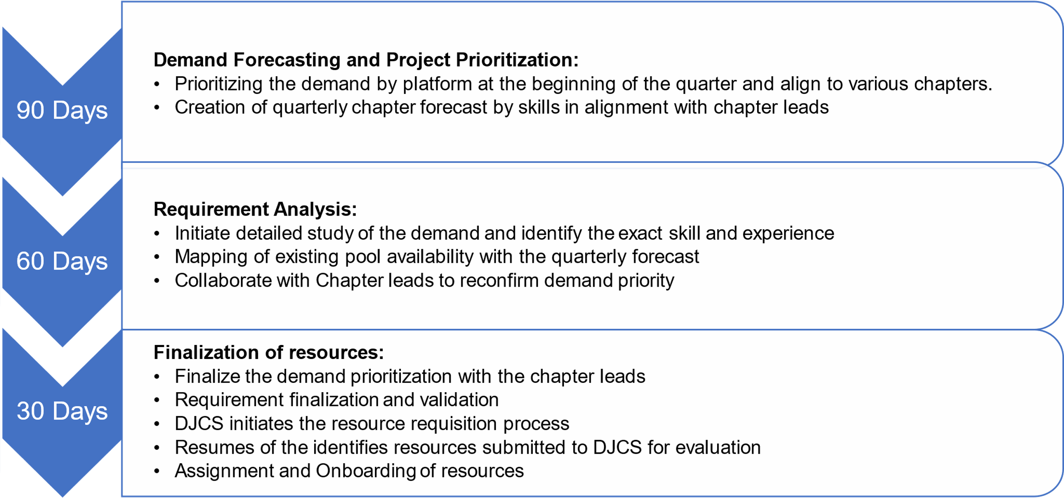
A Quick view of our Proactive Demand Management Framework:

The above-mentioned demand management framework is further enabled by our multi-lever approach to identify and grow talent. This includes:

Topcoder for Crowdsourcing and Demand Fulfilment:
CLIENT can leverage Wipro’s Topcoder platform which is world’s largest crowdsourcing platforms with more than 1.5 million members. This is a thriving community of UX Designers, Data Analysts, Data Scientists, Testers having top-notch skills in their respective areas.
- Through Topcoder CLIENT will get and increased flexibility to manage resource demand, cushion and unforeseen spikes in resource requirements.
- Topcoder can also be leveraged by CLIENT team for an accelerated delivery of discrete cope items of the project like UX/UI design, Performance Testing, Analytics by running micro challenges for a specific scope.
- CLIENT will also advantage from ‘Topgear’ which is the community of Wipro’s technologists enrolled on Topcoder platform. These are full time employees of the wider Wipro ecosystem who can participate in specific scope of work and help fulfil any immediate resource requirements. The cultural alignment of ’Topgear’ with project teams (both Wipro employees) ensures seamless alignment of work with no impact of demand spike on project execution.
Local Resourcing Partners:
- As explained in the first part of this response, Wipro will closely work with local partners for any demand fulfilment for niche skillset.
Leveraging Wipro’s Existing Talent Pool: (Wipro Fulfilment Engine)
- Mining Wipro’s talent pool of talent with the skills having the right fit for the requirement.
- Fresh Campus recruits enabled with CLIENT Digital Academy trainings.
- Identification of resources looking for a project change or about to be released from an ongoing engagement.
Digithon for Talent Identification: (Wipro Enablement Engine)
- A hackathon contest designed for recruitment objectives and identified candidates who rightly fit for the role and skill requirements.
- Running hackathon events to identify best talents from boutique firms and start-ups.
Lateral Hiring: (Strategic Hiring)
- Identified base on Social Media campaigns, screened for technical vitality, role fitment and culture fitment in addition to skills.
- Reached through our career sites, internal job sites, direct ad campaign, recruitment partners and employee referrals.
To conclude, we ensure that we have the program fully covered from the resourcing perspective through all the sourcing models as articulated in this section – though community sourcing mechanism (TaaS/Topcoder, our internal sourcing methods, our local partner who bring only the niche skills identified for NextGen).

Overview of project resources
Provide an overview of the resources that will deliver services highlighting how they will support the NextGen Program.
How will these resources support (Role/Responsibility) the services:
We have articulated, below, the roles the resources that we have proposed (above section) will play to support the delivery of the program:

Role | Responsibility in the Program (How they will support)
Agile Coach | - Advisory support to the team of Innovation Lighthouse  - Work on PI planning, support acceleration cells  - Advisory role to set the Sprint velocity.
DevSecOps Architect | - Build CI-CD-CT pipeline  - Use Digital Rig IP to fetch dashboard view,  - Report DevOps adoption and efficiency metrices
Enterprise Architect | - Engage PO during the Co-design phase  - Provide guidance on innovation cell under Lighthouse construct  - Work closely with CLIENT businesses, PO
Testing Manager | - Be involved form the 1st Sprint  - Provide testing coverage per sprint  - Plan test automation, functional, performance test during developmental sprints  - Support UAT before each Release.
Program Director | - Overall Governance support  - Ensure resource demand management  - Manage multiple sprints  - Engage key FEW business/user community  - Participate and report project metrices during key stakeholder meetings/reviews.
Pega Architect | - Build different low-level design components for PGP  - Review all the architectural, design, development artifacts.  - Ensure the key technical hotspot areas are covered in the design and development.
Pega Technical Lead | - Performs configuration activity using PGP  - Performs Unit testing of code.  - Ensure the functional specifications reconfigured using Pega platform
Pega Lead Business Architect | - Translates persona into user stories  - Maps the user stories into prod features, scope  - Performs end to end functional testing before UAT
MuleSoft Architect | - Analyses various interface points  - Assesses traffic requirement  - Writes API services and makes available before the unit testing
MDM Architect | - Master data management and Reference data management  - Data Governance activity – define data policies  - Performs and checks data synch issues
Oracle Consultant | - Support OIC activities for setting up AP/AR  - Help in building service interfaces to be exposed to PGP for accounting services
Oracle Integration Consultant | - Will bring in expertise in accounting related integration services to/from the orchestration layer.
Drupal Architect | - Support conversion of wireframes from CLIENT to HTML  - Analyse user journey, screen flow, define number of screens, etc.
Data migration lead | - Synchronize the Change data capture from the VIEW application to Next Gen application  - Migrating VIMS data dump  - Transferring eligible VIEW obligations to NextGen
Data Governance | - Define Data Policies at the enterprise level  - Steer Data Quality & compliance related governance
Cloud Security Architect | - Cloud Security Architecture Design (Landing Zone)  - Define Infra & network security components  - Recommend logging policies, security monitoring
TRIM Consultant | - EDRMS design (including classifications and disposal schedules), configuration, documentation, and training presentations for records management  - Data analysis and cleansing  - Assistance with resolution of any UAT issues
TRIM Consultant | - Development, Test and Production environment deployment  - Post-implementation support

Experience in delivering services

CLIENT Service Delivery Principles
 | Principle | Intent
PD-01 | Plan and build to clearly defined target state while delivering value incrementally | The intent of this principle is twofold: (1) to enable Agile-style delivery to be conducted in a safe manner and (2) to discourage monolithic waterfall projects where the value to be delivered is deferred until the end of the project.
PD-02 | Maintain parallel operations to ensure business continuity and seamless transition | When implementing solutions, the transition needs to be fully considered, both from a technical as well as from an organisational point of view.
PD-03 | Rigorously test and verify all functional components before releasing into production | Nothing is released into production that puts the delivery of government services and the reputation of the government at risk.
PD-04 | Leverage common service and/or infrastructure capability where functionally and operationally aligned | Capability within whole of Victorian government should be re-used and/or enhanced to enable reuse where fit for purpose.
PD-05 | Maintain development and deployment independence to avoid being constrained by third parties and/or competing priorities | Fines Victoria should set its own release velocity.
PD-06 | Automate testing and deployment to increase speed and quality and constrain cost | Once a solution or platform has been built, the functionality that is released onto that solution should be deployed automatically and automatically tested along the way.
PD-07 | Prioritise deployment of common service modules and platforms to maximise value realisation and constrain technical debt and rework | Strategic foundation components should be laid down before they are needed. If they are not ready, then workarounds should be avoided.
PD-08 | Co-design solutions with delivery partners to engender shared understanding and ownership | Delivery partners should be fully engaged in the co-creation of solutions to business problems rather than simply delivering technical services. Co-design enables greater capability to be brought to bear on a problem and is a powerful mechanism for creating aligned and synergistic interests between different stakeholders.
PD-09 | Drive quality assurance and outcomes through co-design and robust business and technical solution assurance processes | Solutions designed by delivery partners should not be delivered without a robust quality assurance process that is owned by Fines Victoria and fully embraced by the delivery partner.
PD-10 | Maintain accountability even where risk is shared | Outsourcing an activity shouldn’t be a matter of hand-passing a problem to a third party and then leaving it entirely up to the third party to manage. Work effort may be outsourced, but a “stub” needs to remain in place organisationally so that the service provider is governed properly.
PD-11 | One team culture characterised by multi-disciplinary teams working collaboratively and transparently to achieve shared success | Organisationally heterogeneous projects should be collectively homogenous.

Our Response On: Compliance to Delivery Principles

PD # | Wipro’s Compliance | How we deliver
PD-01 | Fully met | We have adopted Agile delivery methodology in concurrence with Program Increments (PI) as defined by you in the document Part B Technology Solution Specification under Section 7. Furthermore, during the Co-design phase (even prior to that, during the POC phase) we will be in better position to bring more granularity in terms of sprint/PI plan, so that the actual business value can be delivered in time and budget for the specific Epics. Illustrated under the table of scope coverage under sec 2.3 scope of services.
PD-02 | Fully met | Starting from Release 1, until the complete transition from VIEW system to NextGen, we have proposed a layer to Run & Operate, while the remaining PIs/Functionalities are getting delivered, we will continue to support the MVPs through s dedicated team working in parallel with the development spring teams. This is articulated under high level implementation plan under sec 2.3.
PD-03 | Fully met | We have proposed a “left-shift” approach in our testing scope, so that we continue doing testing along with our CI-CD activities (CI-CD-CT) iteratively and much advance in the SDLC. We plan to deploy one of the key Wipro IPs in this scope. Fully covered under our testing strategy under sec 2.3
PD-04 | Fully met | In our solution approach and consequently in our commercial response, we have indicated to use those components of CLIENT that are functionally aligned to NextGen requirements. For example – for the OCR capability we have not used any additional component, for the Mail Room service, we have not introduced any other process, and likewise, to ensure reusability in our solution approach.
PD-05 | Fully met | In our digital pod construct – our ONE team approach – we have factored the PO and the SM from CLIENT, in order that the team can be aligned with regards to business priorities (Epics) and the sprint velocity. Fully adhered to this in our explanation of team structure under sec 2.3
PD-06 | Fully met | To achieve fully automated testing and deployment, we have introduced Automation Testing as part of our CT activity along with the CI-CD stack we have proposed in our Solution Architecture Response. Covered more elaboratively sec 2.3 under Testing function.
PD-07 | Fully met | In our project implementation plan (provided as part of Sec 2.3 of this document), we have budgeted our effort/time towards the Foundation PI where we are enabling the technology stand-up for the development cycle to start, to avoid any work around/quick fixes.
PD-08 | Fully met | We are fully in concurrence with the Co-design approach to program deliver, especially considering a multi-disciplinary team, and have factored our efforts/time towards the same in our commercials too. We have articulated this under sec 2.3 under our agile delivery illustration.
PD-09 | Fully met | At every sprint level we have planned for CLIENT quality assurance to be executed through UAT activity, which should be in line with our PI planning done prior to the beginning of the phase itself, before the same goes to Release. Pls refer sec 2.3 for coverage on Testing function.
PD-10 | Fully met | We have ensured we have a strong governance layer in place and a period metric to be published to the program steer, which we have articulated in section 2.1 of this document, as one of critical success factors.
PD-11 | Fully met | We have considered this as one of the key success criteria of this program and have therefore, adhered to construct our delivery pod that consists of mix of multiple resources including CLIENT personnel. Pls refer to Sec 2.1 KSF # 8 for more illustration.

Case studies
Provide three examples of successful implementation engagements where you have delivered your proposed technology solutions in context of similar scale and complexity within government or large organisations within the last 5 years.

The case studies must contain the examples provided in your response to Part D Schedule 4 Business Scenarios and detail how the case study addresses the CLIENT delivery principles as specified in section 4.1

Referees from the case studies are to be provided. CLIENT reserves the right to contact/site-visit clients of Tenderers. If you are proposing a sub-contractor or partnership model please include case studies which are representative of your past experience in the delivery of such models.

The case studies are to be succinct and contain only information relevant to the requirements of this RFT.

